**DATA ANALYTICS WITH TABLEAU**

**1. INTRODUCTION**

**1.1 Overview**

Data analytics converts raw data into actionable insights. It includes a range of tools, technologies, and processes used to find trends and solve problems by using data. Data analytics can shape business processes, improve decision-making, and foster business growth.

As a term, data analytics predominantly refers to an assortment of applications, from basic [business intelligence](https://www.techtarget.com/searchbusinessanalytics/definition/business-intelligence-BI) (BI), reporting and online analytical processing ([OLAP](https://www.techtarget.com/searchdatamanagement/definition/OLAP)) to various forms of [advanced analytics](https://www.techtarget.com/searchbusinessanalytics/definition/advanced-analytics). In that sense, it's similar in nature to [business analytics](https://www.techtarget.com/searchbusinessanalytics/definition/business-analytics-BA), another umbrella term for approaches to analyzing data. The difference is that the latter is oriented to business uses, while data analytics has a broader focus.

The topic of my project is **“Visualisation tools for electric vehicle charge and range analysis.”**

**1.2 Purpose**

Tableau is a data visualization tool first and foremost. Therefore, it’s technology is there to support complex computations, data blending and dashboarding for the purpose of creating beautiful visualizations that deliver insights that cannot easily be derived from staring at a spreadsheet. It has climbed to the top of the data visualization heap because of it’s dedication to this purpose.

Creating charts. The simple way to do it is to drag the categories into the 'Row' and 'Column' fields. Let's drag the 'Region' category into the Rows and the 'Sales' Category into Columns. Tableau then automatically creates a bar chart for us.

Using data analytics applications, the companies were able to find the best shipping routes, delivery time, as well as the most cost-efficient transport means. Data analytics is important because it helps businesses optimize their performances. Implementing it into the business model means companies can help reduce costs by identifying more efficient ways of doing business and by storing large amounts of data.

**2. PROBLEM DEFINITION AND DESIGN THINKING**

**2.1 Empathy Map**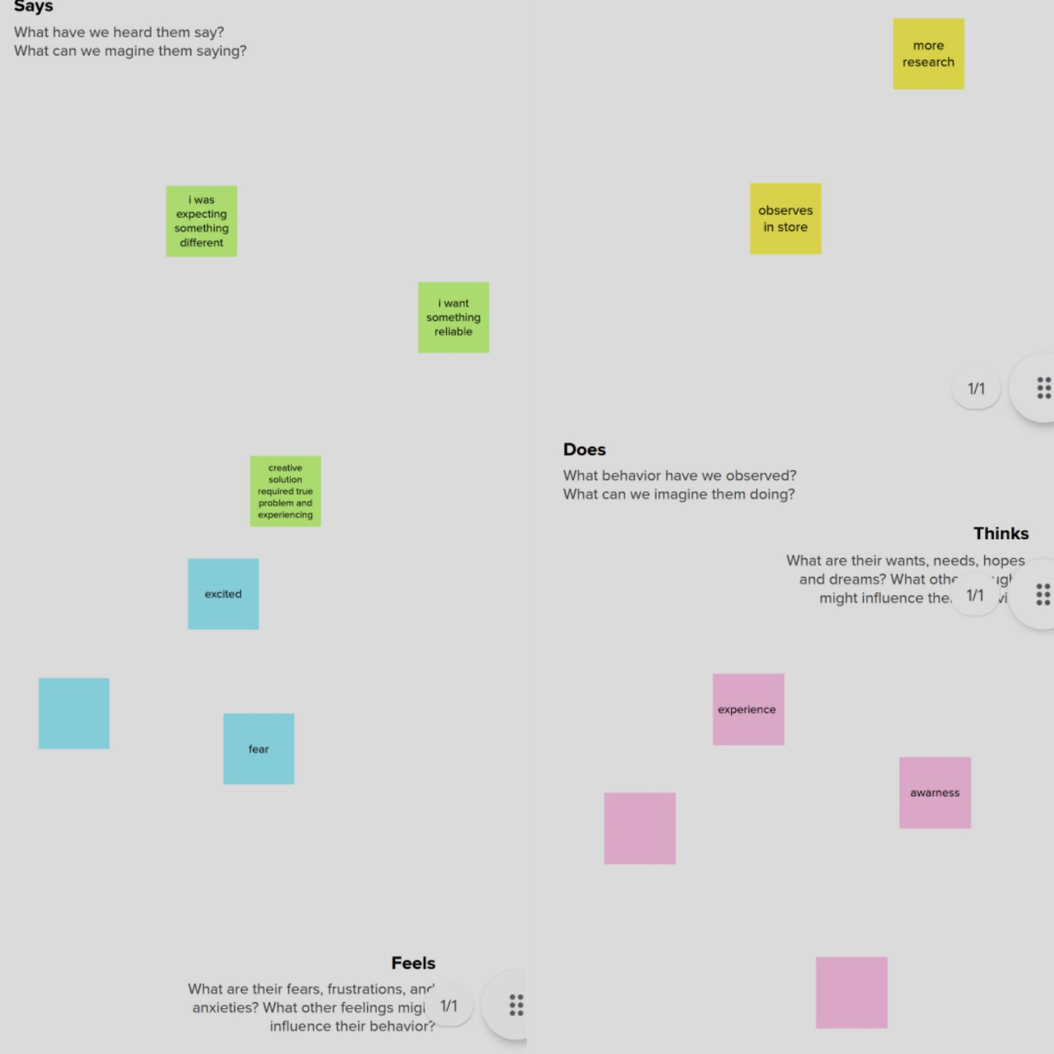

**

**3. RESULT**

Output of the Project

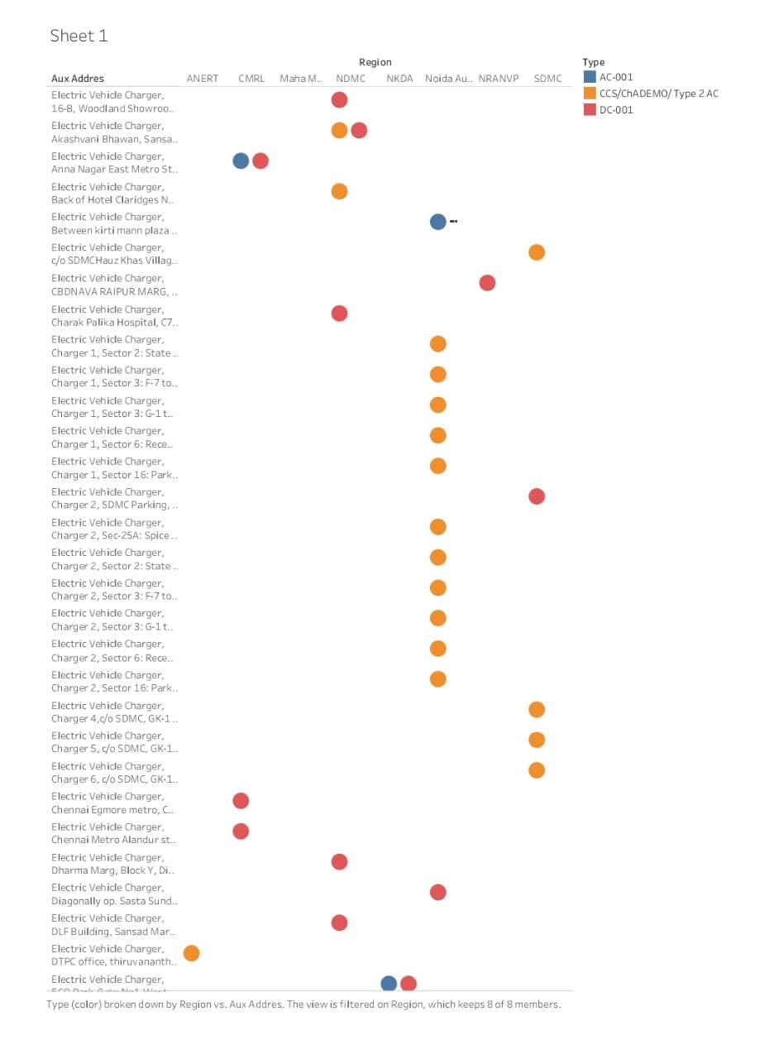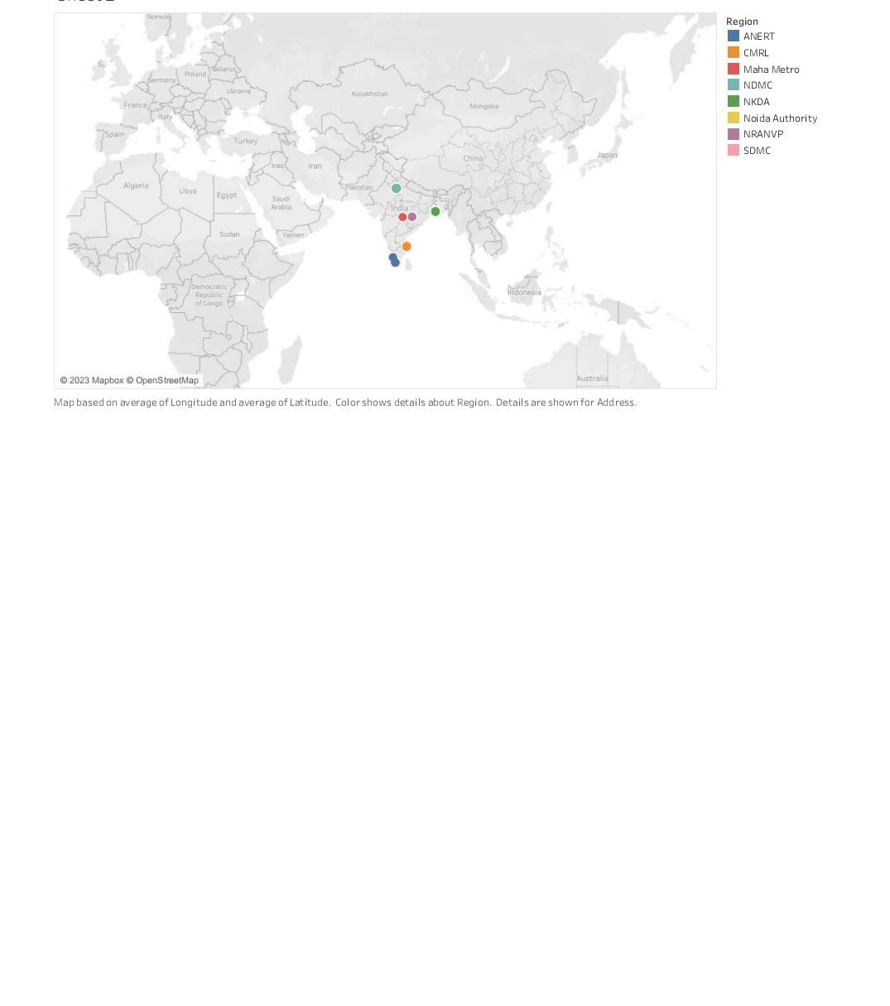

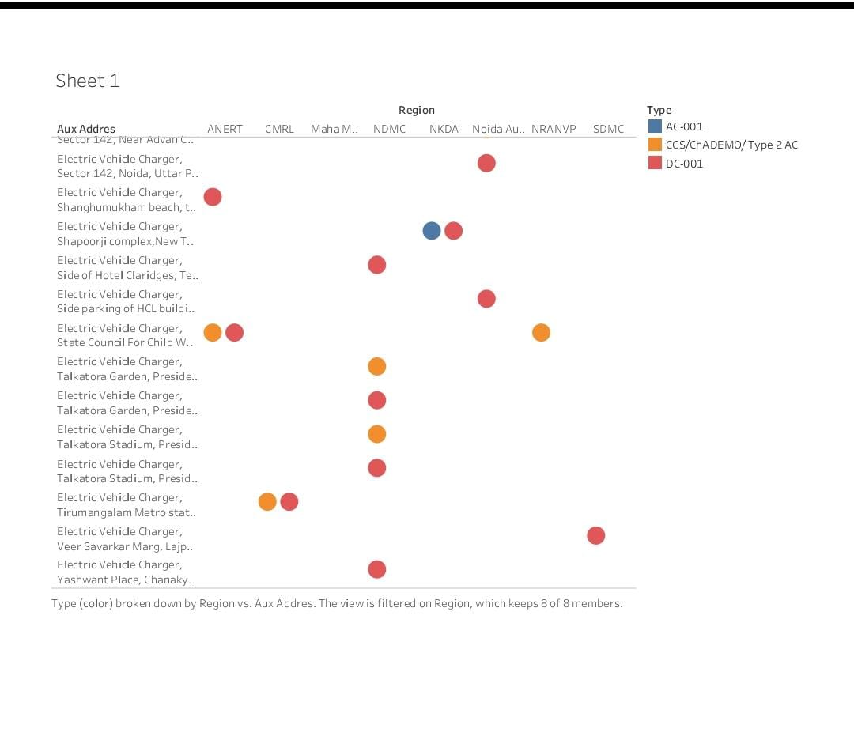

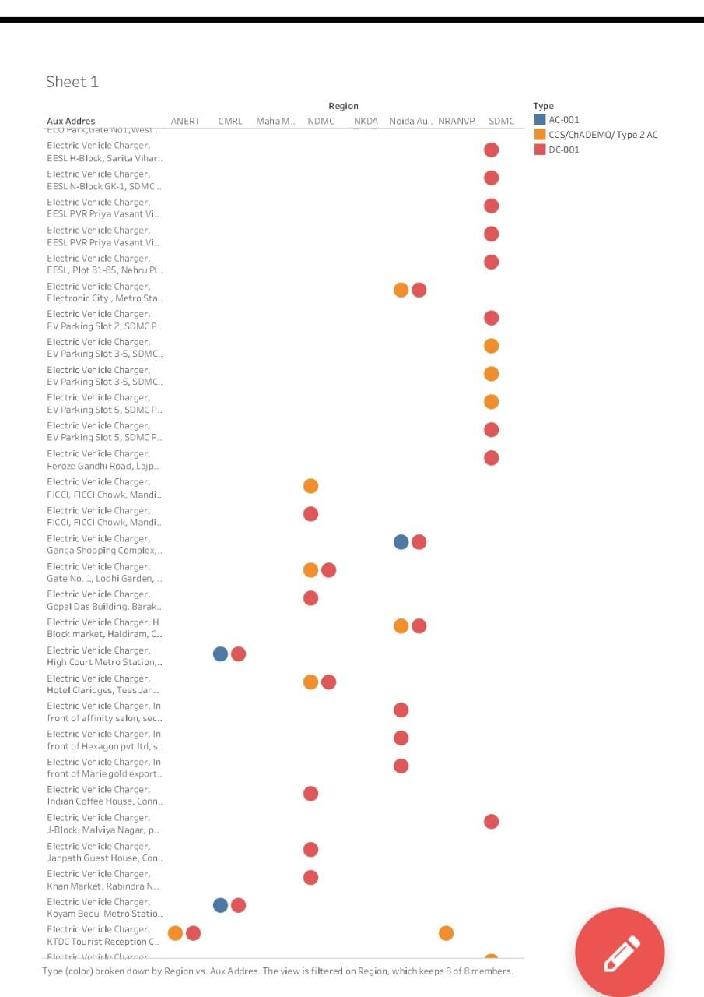

**4. ADVANTAGES AND DISADVANTAGES**

**4.1 Advantages**

Advantages of Electric Vehicles

Eco-friendly: Because electric vehicles do not utilize fuel for combustion, there are no emissions or gas exhaust. Vehicles that run on fossil fuels contribute significantly to hazardous gas accumulation in the environment, thus driving an electric car can help contribute to a cleaner environment.

Renewable energy source: Electric vehicles run on renewable power, whereas conventional automobiles function on the combustion of fossil fuels, which reduces the world’s fossil-fuel stocks.

Less noise and smoother motion: Driving an electric car is significantly smoother. Because they lack fast-moving elements, they are quieter and produce less noise.

Cost-effective: Electricity is far less expensive than fuels such as gasoline and diesel, which are subject to regular price increases. When solar electricity is utilized at home, battery recharging is cost-effective.

Low maintenance: Because electric cars have fewer moving components, wear and tear is reduced when compared to traditional auto parts. Repairs are also simpler and less expensive than combustion engines.

Government support: Governments throughout the world have granted tax breaks to encourage people to drive electric vehicles as part of a green program

**4.2 Disadvantages**

Disadvantages of Electric Vehicles

High initial cost: Electric vehicles continue to be quite expensive, and many buyers believe they are not as inexpensive as traditional automobiles.

Charging station limitations: People who need to travel long distances are concerned about finding adequate charging stations in the middle of their journey, which are not always accessible.

Recharging takes time: Unlike conventional automobiles, which require only a few minutes to replenish their gas tanks, charging an electric vehicle takes many hours.

Limited options: Currently, there aren’t many electric car models to pick from in terms of appearance, style, or customized variations.

Less driving range: When compared to conventional automobiles, electric vehicles have a shorter driving range. Electric cars can be convenient for short-distance travel but are inconvenient for long-distance travel.

**5. APPLICATIONS**

Electric vehicles use electricity to charge their batteries instead of using fossil fuels like petrol or diesel. Electric vehicles are more efficient, and that combined with the electricity cost means that charging an electric vehicle is cheaper than filling petrol or diesel for your travel requirements.

**6. CONCLUSION**

In this paper, a description of how to develop a time and space model to evaluate the energy demand of large-scale electric bicycle based on survey and Geographic information is presented. Meanwhile, a method which could precisely deliver the energy demand on space was developed. The case study was based on Nanning, a city with 1.7 million electric bicycles in China. The dataset includes 1574 data samples. The results show that the electric bicycle charging demand has the following characteristics: The space model of Electric bicycle charging demand shows that the demand has a concentrated trend, in which it mainly concentrated in the urban area and decreased toward spreading suburbs. There is a large potential of business value for charging pipe managing company. Charging demand for electric bicycle will be 1.33% of total and 4.6% of domestic consumption for Nanning. It witnessed a maximum to minimum ratio about 20 times, which implies it has a great value for demand side management.

**7. FUTURE SCOPE**

This growth is supporting the data analytics industry with a great increase in the amount of data collected, which can be used to tap into several different sectors in the market. **There has already been a 26.5% year-on-year growth in the data analytics industry in 2021It will also help in creating various employment opportunities**. The study further points out that the industry is expected to create over 11 million jobs by 2026.

**8. APPEDIX**

* GitHub
* Tableau
* My SQL
* Mural